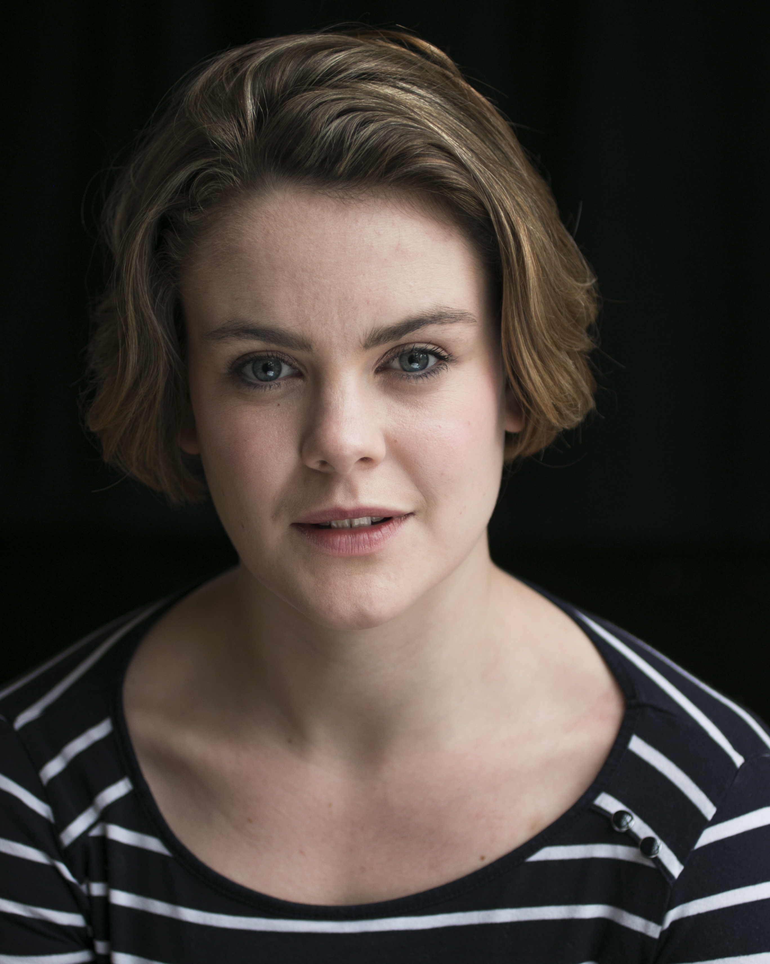
Agent:
Gardner Herrity
24 Conway Street
London
W1T 6BG

Phone:
02073880088

Email:
info@gardnerherrity.co.uk
Hair: Brown

Eyes: Blue

Height: 5’3”

Spotlight Pin:

9494-0190-0666

Graduate of Bristol Old Vic Theatre School
Molly Hanson
Gardner Herrity
Theatre Credits:

Toby Maitland, POSH, Pleasance Theatre with Can’t Think Theatre Company,
Directed by Cressida Carré
Ugly Sister, Cinderella, Windsor Castle with Watch Your Head,
Directed by Sasha McMurray
Hermia, Midsummer Nights Dream, Windsor Castle, with Watch Your Head,
Directed by Sasha McMurray
Celia, As You Like It, Savill Gardens, with Watch Your Head,
Directed by Sasha McMurray
Joan, premier revival of First Episode, Jermyn Street Theatre, with Primavera Productions,
Directed by Tom Littler

Television Credits:

Hannah Drake, The Coroner (Series 1 Episode 3 - That’s The Way To Do It), BBC,
Directed by Matt Carter.
Paulette Swain, Father Brown (Series 4 Episode 1 – The Mask of the Demon), BBC,
Directed by Paul Gibson.

Other Credits:

Various Vocals for the London Road Cast Recording, Cuba Pictures, BBC Films.

